Git Version control System

Version control system is a process to store all members changes in centralized location and keep track all changes being done in the csv by whom,When,Why.it tracks the developers,testers changes how many times it changes in code level.

How to Download GIT

Step1:Got this URL---- <https://git-scm.com/downloads>

Step2:Select which OS u want ex:Mac OS,Windows etc

I am using windows

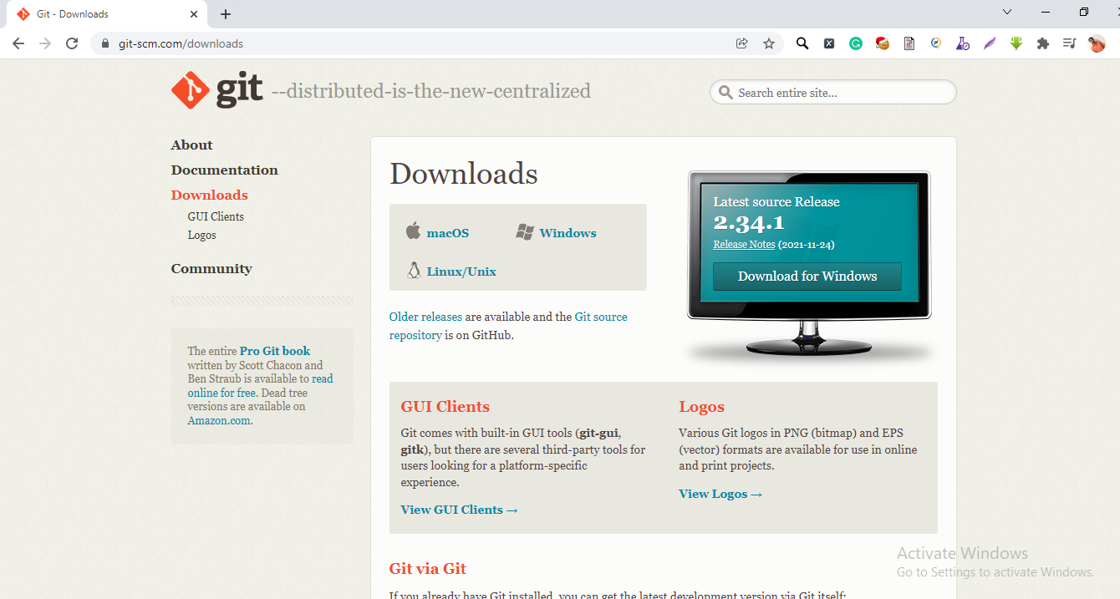

Select Executable set up windows bit version 32 or 64 bit

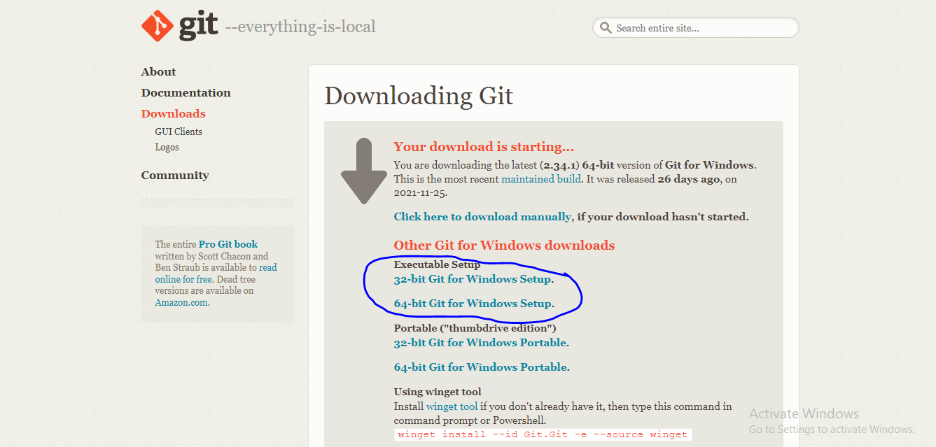

Store any where

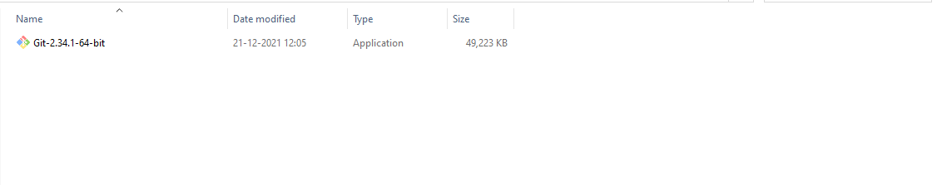

Double click the icon and Click Next button until finish

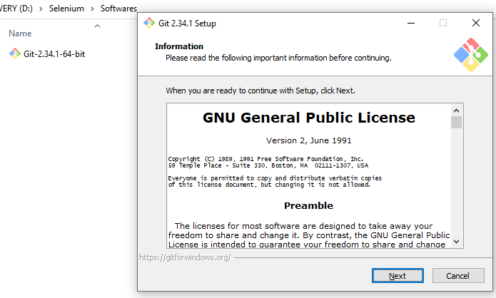

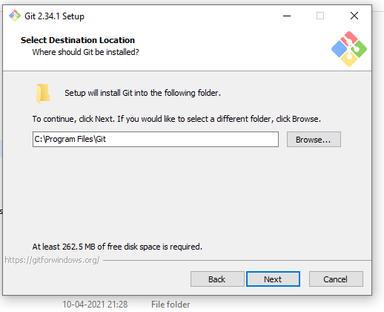

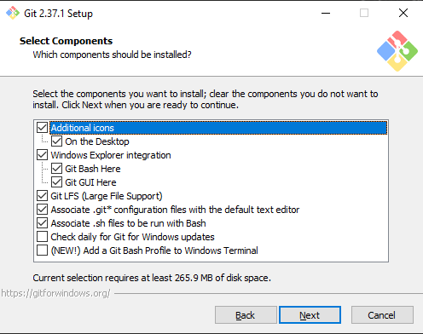

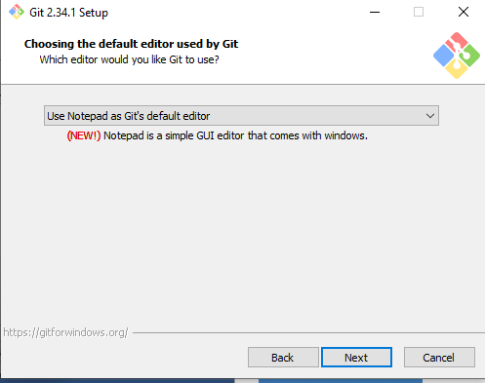

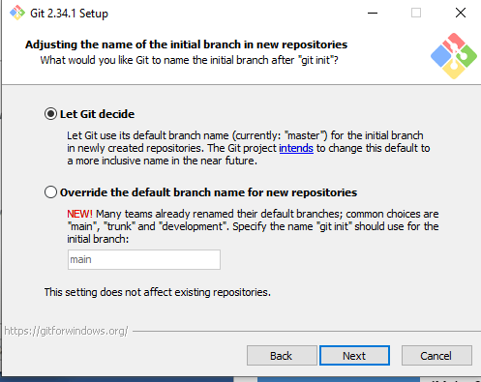

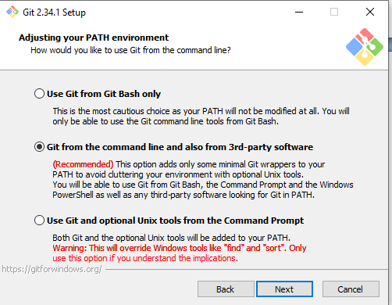

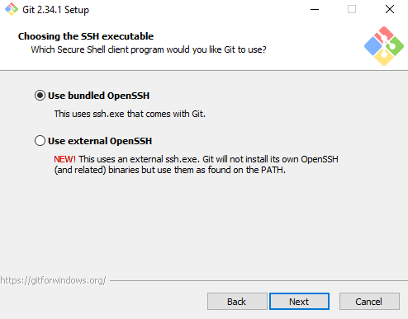

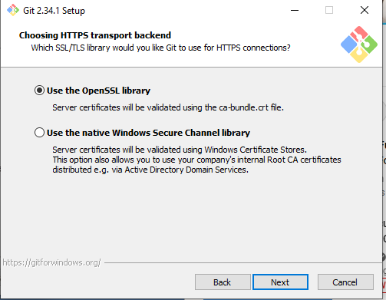

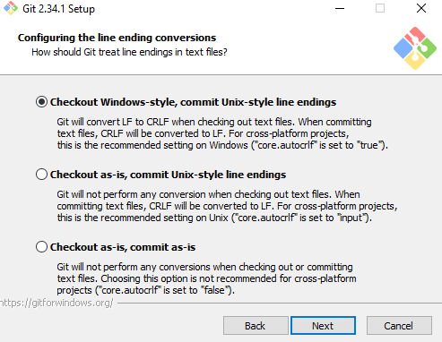

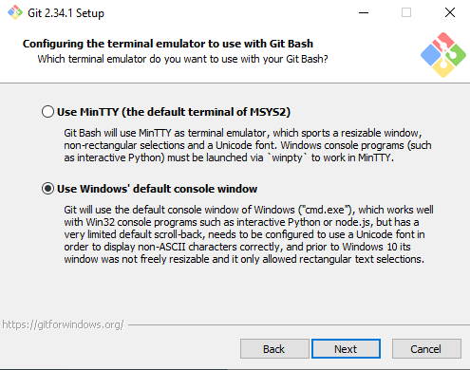

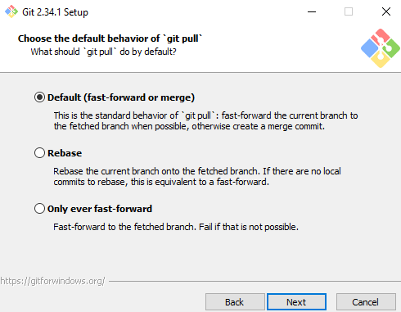

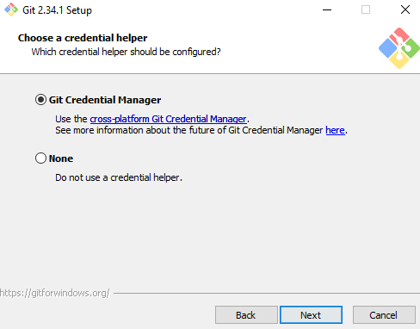

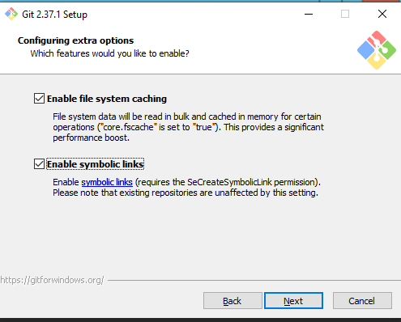

Don’t select any thing below option below Image .Click Install button.

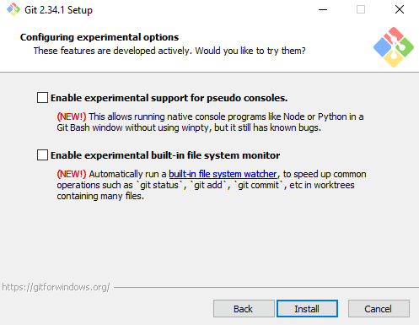

Un check the Check button and Click Finish button

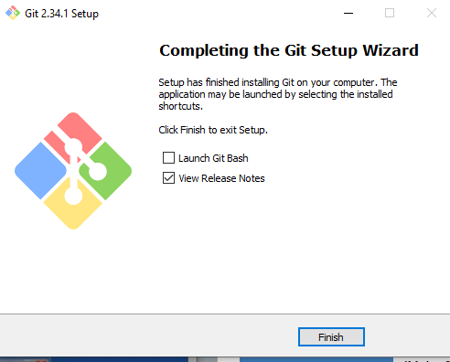

Git is Sucessfully Installed now u can go Start menu and Type Git u are able to see below Picture

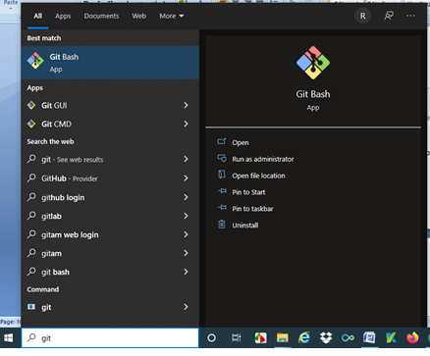

Here we are using complete Linux Commands.

For checking git version use this command git –version

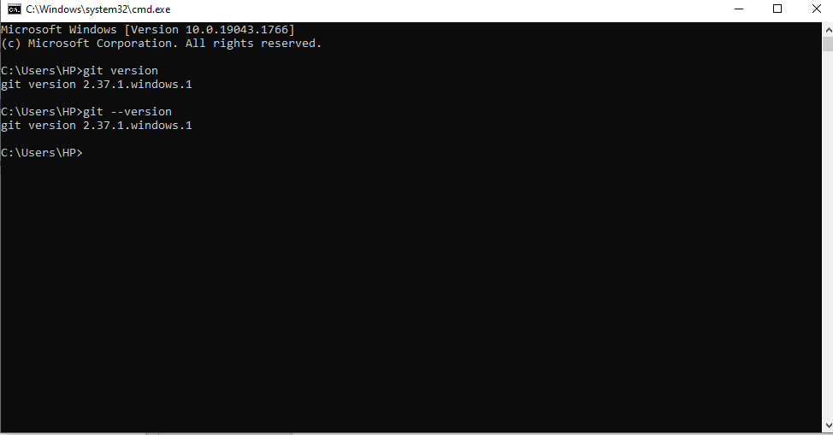

Open Git hub.com

Login Github

Create New repository click “ + “ icon

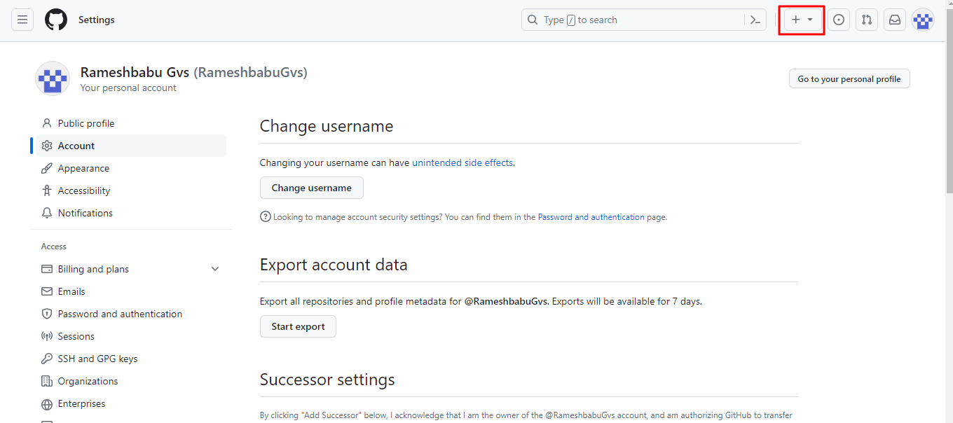

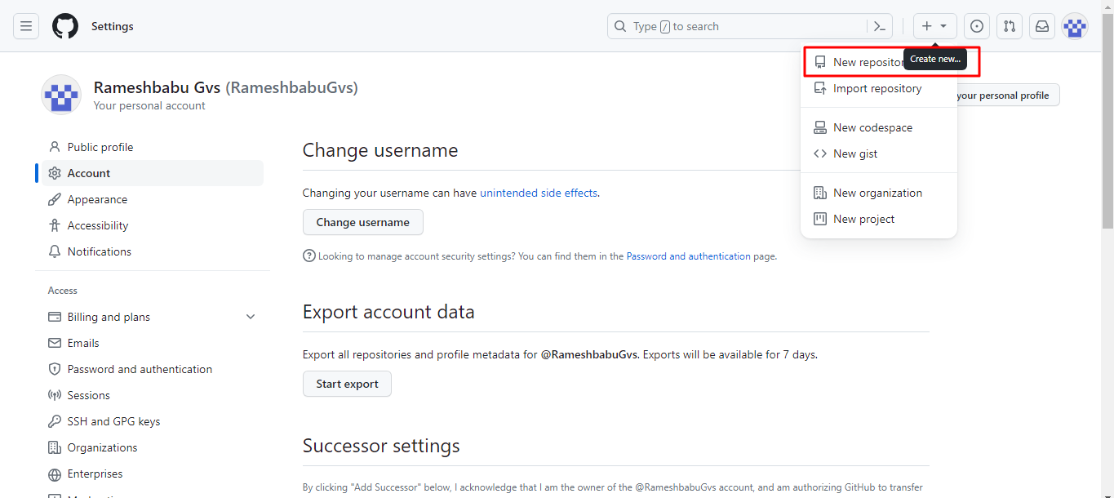

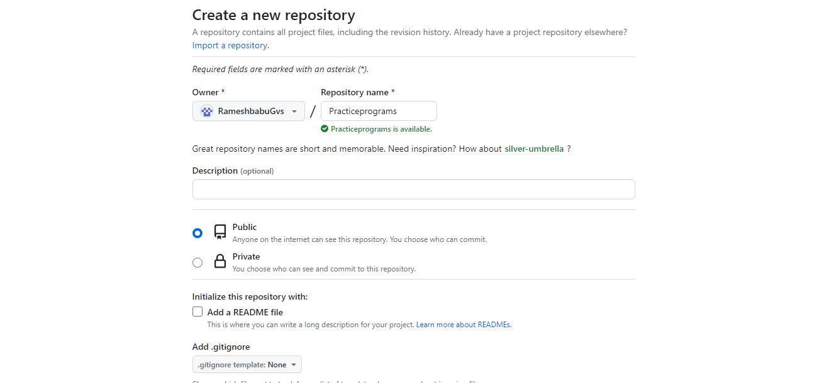

Public means any one can easily access

Click Create repository button

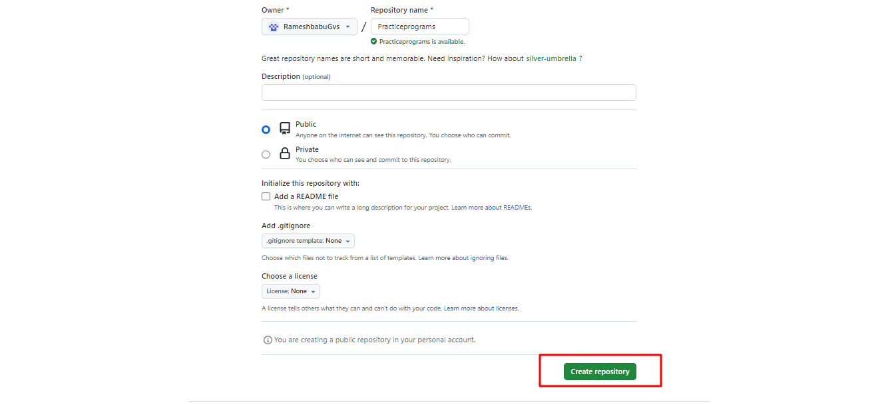

After able to see created repo page and url

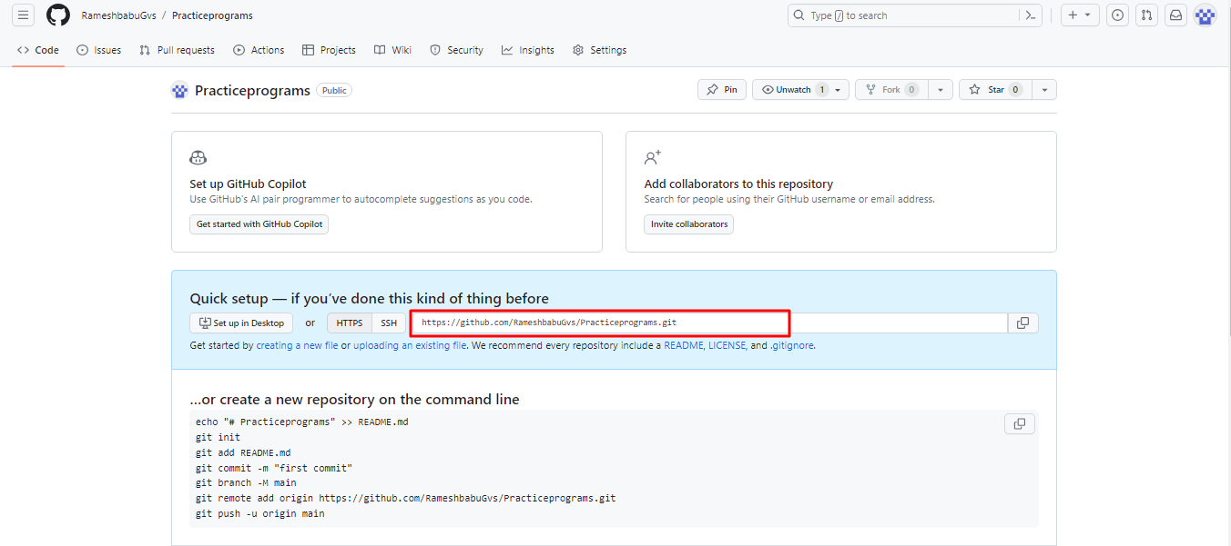

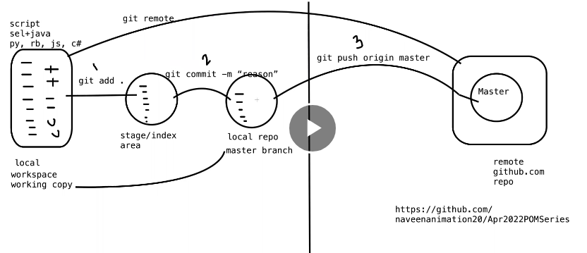

Open cmd

Change the directory enter the project saved path and after check directory moved or not by using pwd command

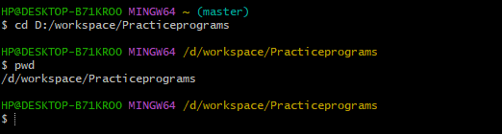

Find the how many directories in current project by using “**ls –alt**“ command

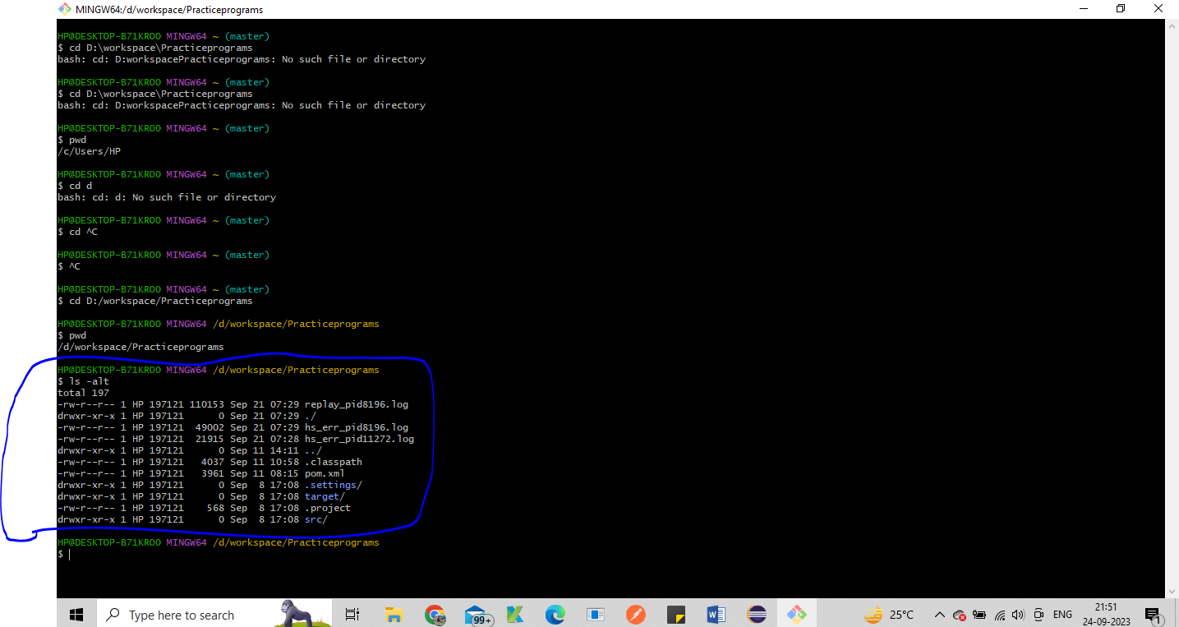

If u want to see the tree view u can see “tree” command

**Add your project into staging area**

if u want to add the untrack files any file u can first initialize the git use below command

**“git init”**

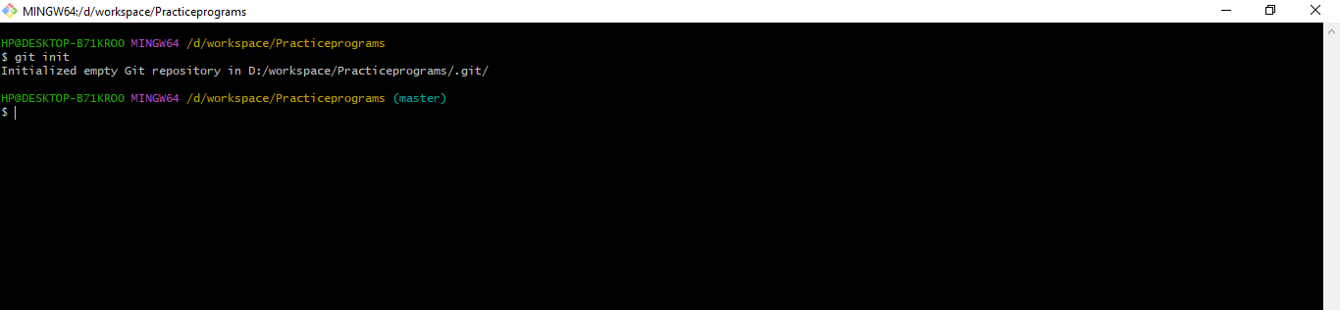

Check the un track files by using below command -- **git status**

**Un tracked files are able to see with red colour text**

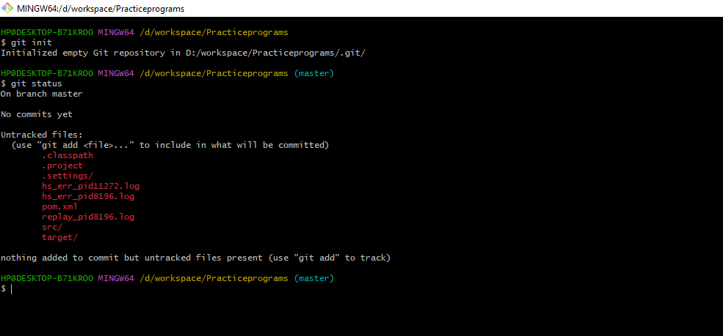

If u want add untracked files to staging area u can use the below command **git add .**

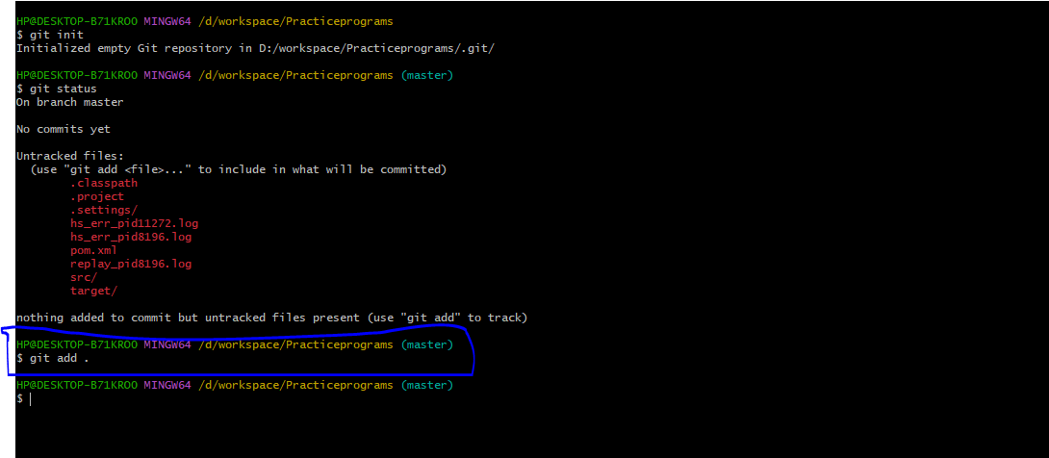

Check git status **git status** : it is used for checking files are added or not

Files are added successfully with green text

Below lines track files

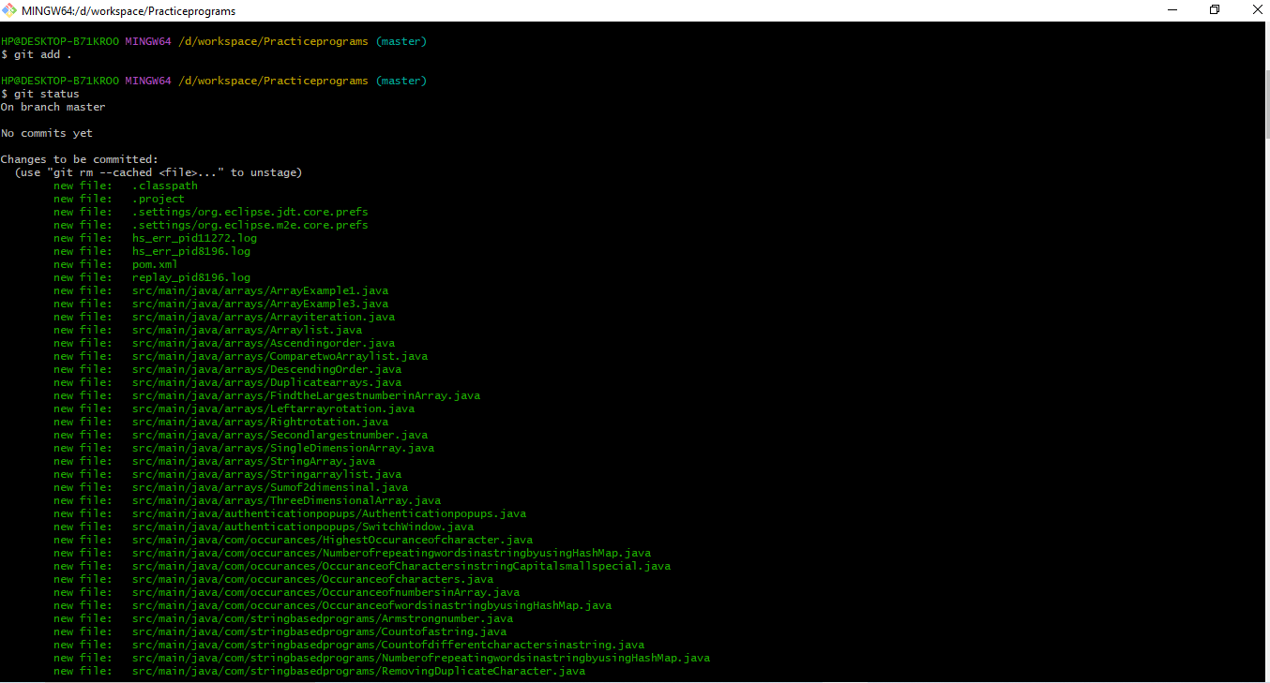

After please try to commit the code – **git commit –m “project files are added”**

**Commit means files are saved only on local repo master branch.**

**It means files are added Staging area to local repo master branch.**

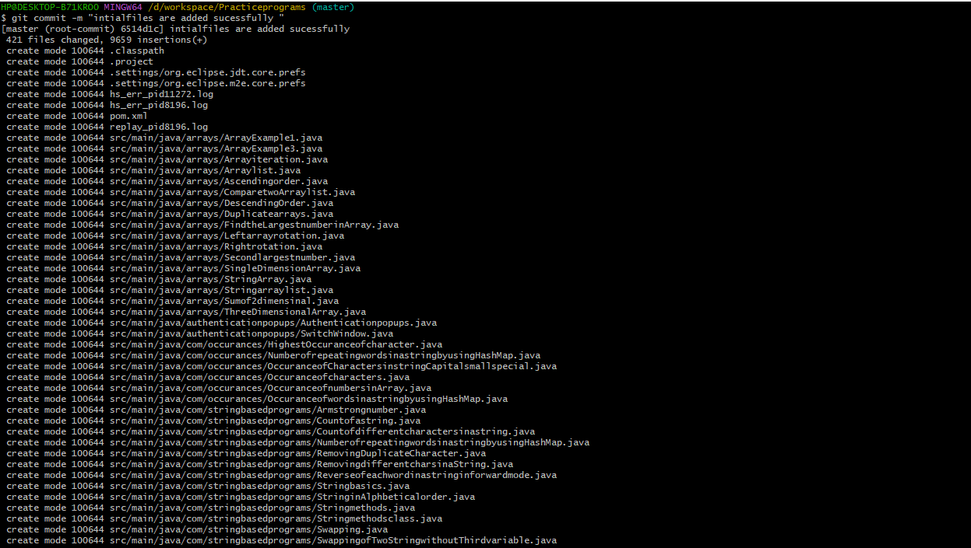

Successfully files are added with white colour text.



U need to give the connection between local to git hub u can use below command:

git remote add origin https://github.com/RameshbabuGvs/Practiceprograms.git

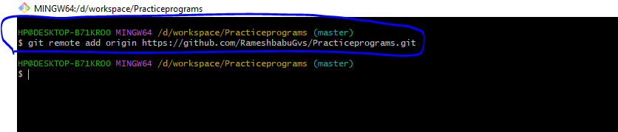

if u is using first time u need give your details some times it asking git hub details

git confi --global user.email “your emailid”

git config –global user.name “Your Name”

How to generate Token for login follow below steps

Go to git hub🡪Profile 🡪Settings🡪Developer settings🡪PersonalAccessToken🡪Token(classic)🡪click Generate new Token

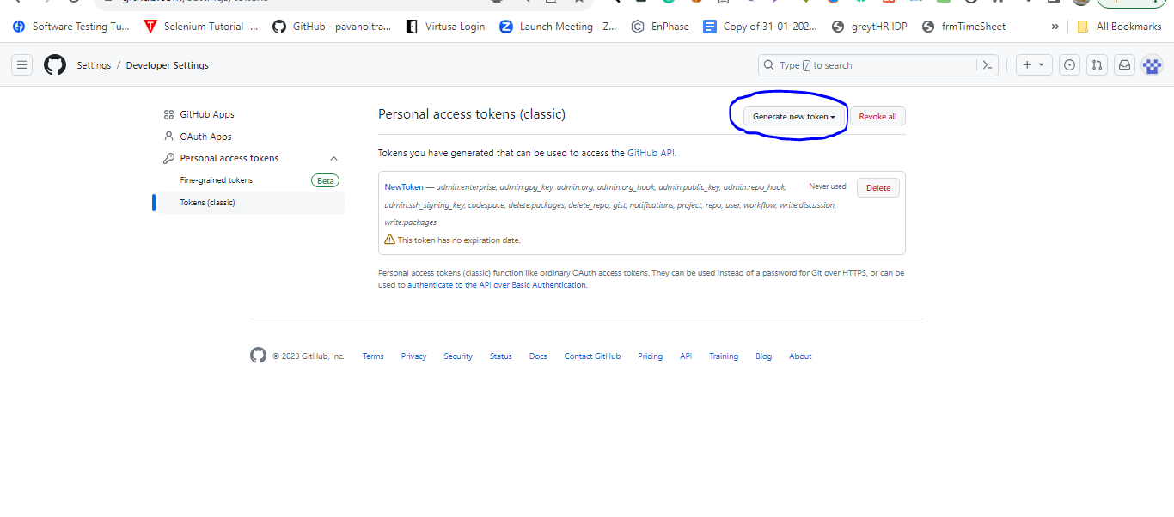

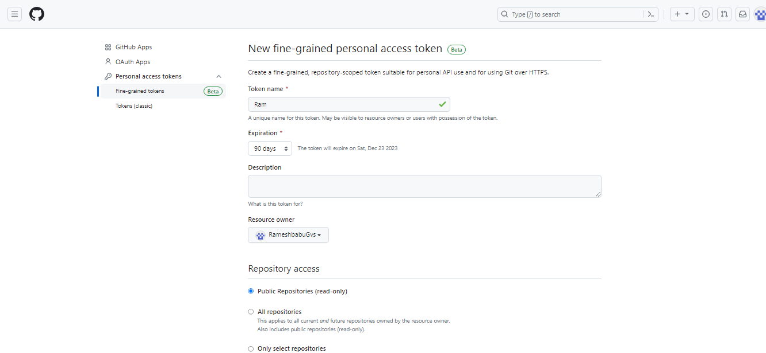

Click Generate Token button

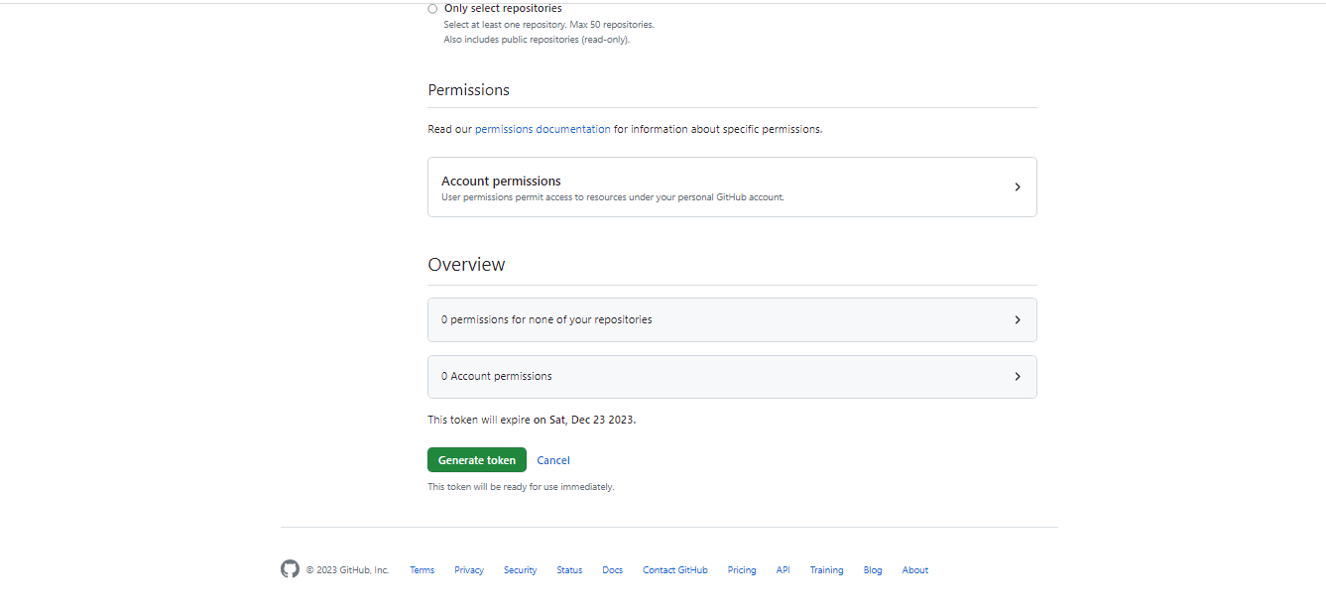

The token id is the password –

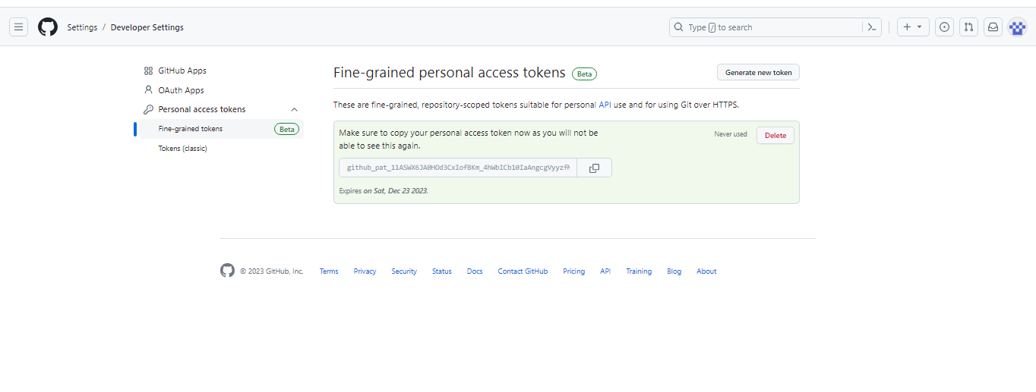

Successfully Pushed the project from local repo master branch to git hub

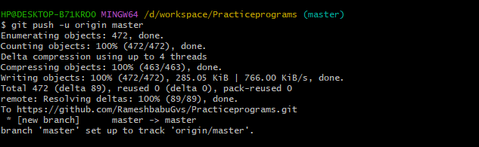

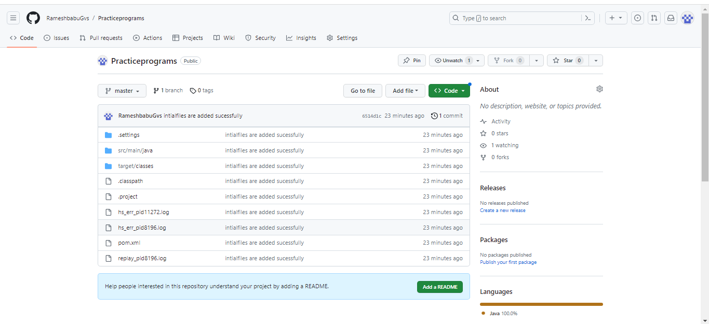

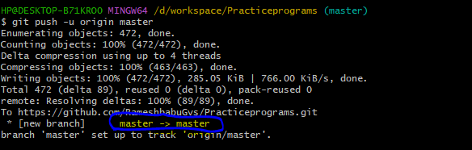

Highlighted text indicates code pushes into master branch

After adding new files into a project again u need to check by using **“git status”**

**U are able to see newly added files(untrack files)**

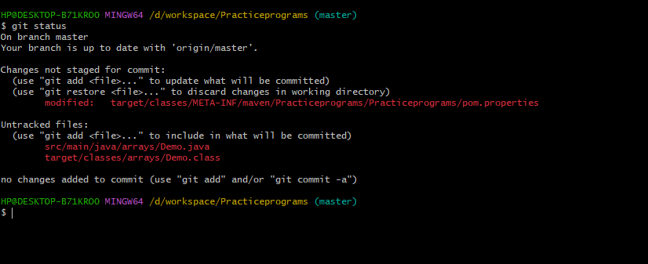

If u want to add local work space files to staging area u can use git add .

If u want to add all files u can use this command 🡪 git add .

But if u want to add only respective file u can use 🡪 git add src/main/java/arrays/Demo.java

Git commit –m “demo page”

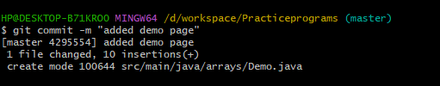

Next push the code to staging to git hub 🡪git push origin master

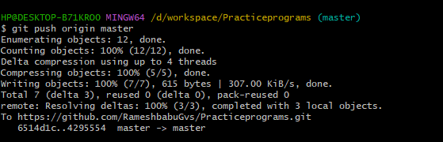

If u want to check the deleted,modified,Created file u can follow above process

Check the git status

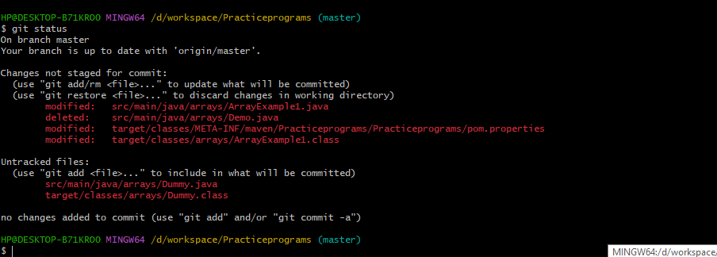

If u want to add local work space files to staging area u can use git add .

But if u want to add only multiple respective file u can use 🡪 git add src/main/java/arrays/Demo.java src/main/java/arrays/ArrayExample1.java src/main/java/arrays/Dummy.java

git commit –m “multiple files added”

**Git Cloning process**

If u have multiple users at the we need to share the project at the we can use clone process. Clone is used for only one time First time for pulling the project.

Open git in local system and change directory by using commands 🡪cd F:/Git

Next check directoty is changed or not by using command 🡪pwd

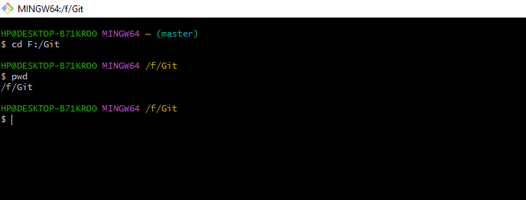

**Next use git clone command with github project url : git clone** [**https://github.com/RameshbabuGvs/Practiceprograms.git**](https://github.com/RameshbabuGvs/Practiceprograms.git)

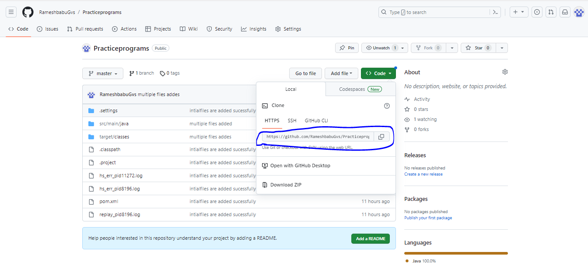

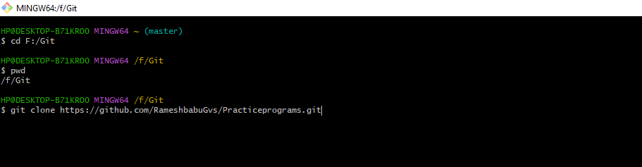

Project successfully cloned

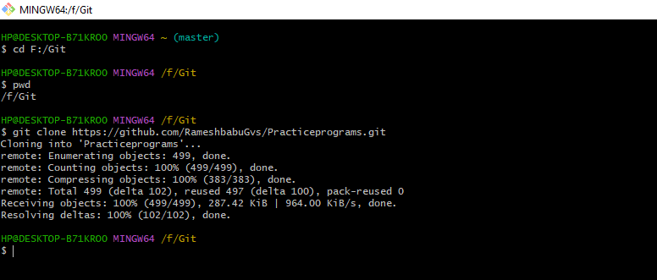

U can check the local folder also successfully cloned or not:

Successfully cloned

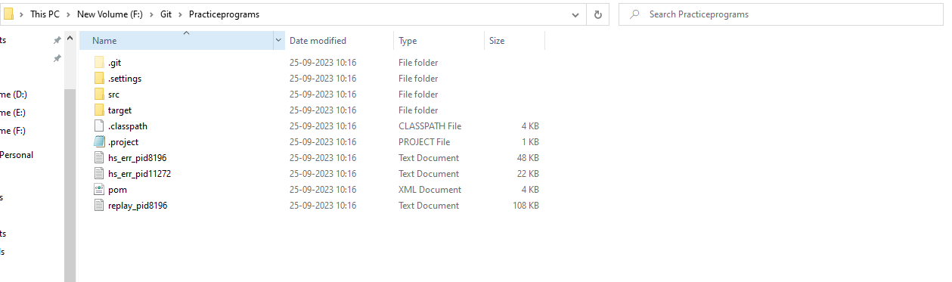

Check the git have how many branches

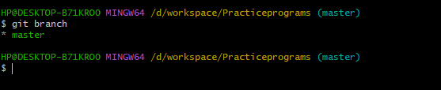it showing only one branch right we are in *master branch with green color letters

**Creation of branch name**

Use below command 🡪 git branch Ramesh



Check branch is created or not

Branch is created successfully with crated name(Ramesh) but it is in master branch

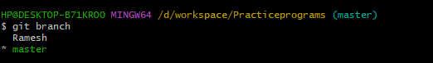

Switch to one branch to another branch

Command🡪 git checkout Ramesh

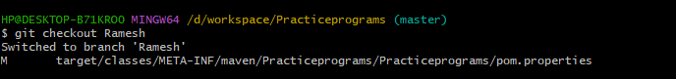

Check branch is move to another branch or not

Command🡪git branch

Successfully move to other branch with green colour text

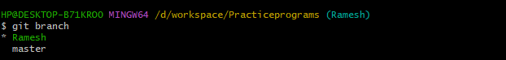

Create one new page in project in Ramesh branch

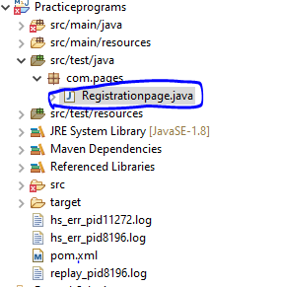

**Next u need to check the git status in Ramesh branch**

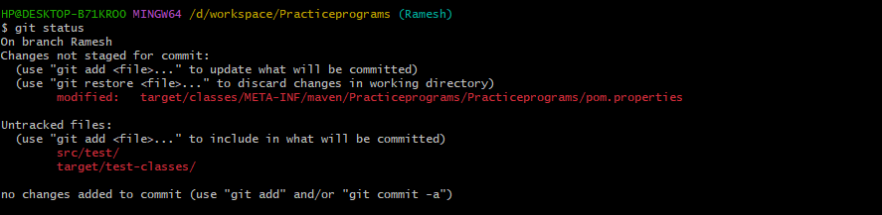

**Next u need to add the files to respective branch**

**If u want only selected files u can git add file**



**Next check status it moves to tracked files or not**

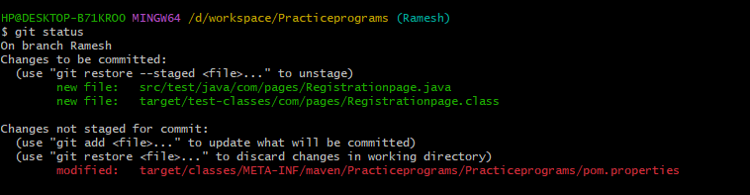

**Next u need to commit**

**Command🡪 git commit –m “added new class in test”**

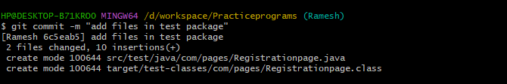

**Commit means files are saved only on local repo Ramesh branch.**

**It means files are added Staging area to local repo Ramesh branch.**

Next u need to push the code into github

In our git hub don’t have Ramesh branch but no need to create the branch when u are push from local repository it is automatically created in GitHub also

By using below command :git push origin Ramesh

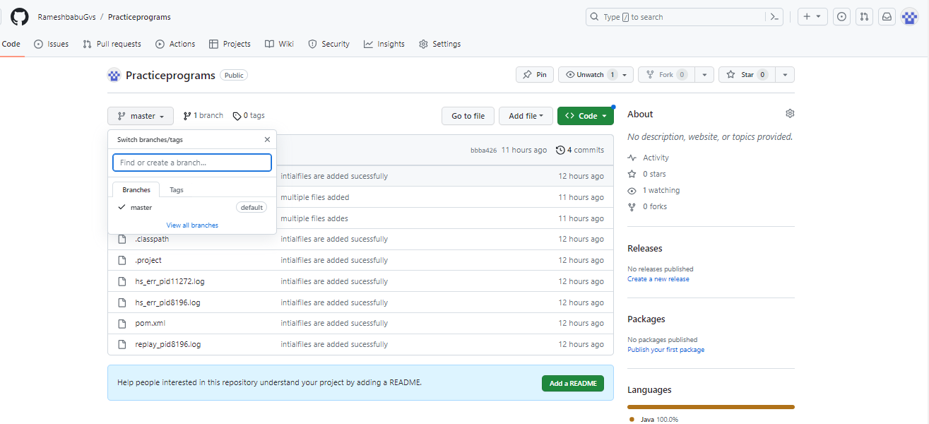

It indicates Data is pushes to Ramesh branch in git hub

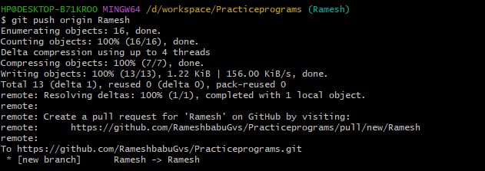

It shows two branches in GitHub and we got one pull request also.

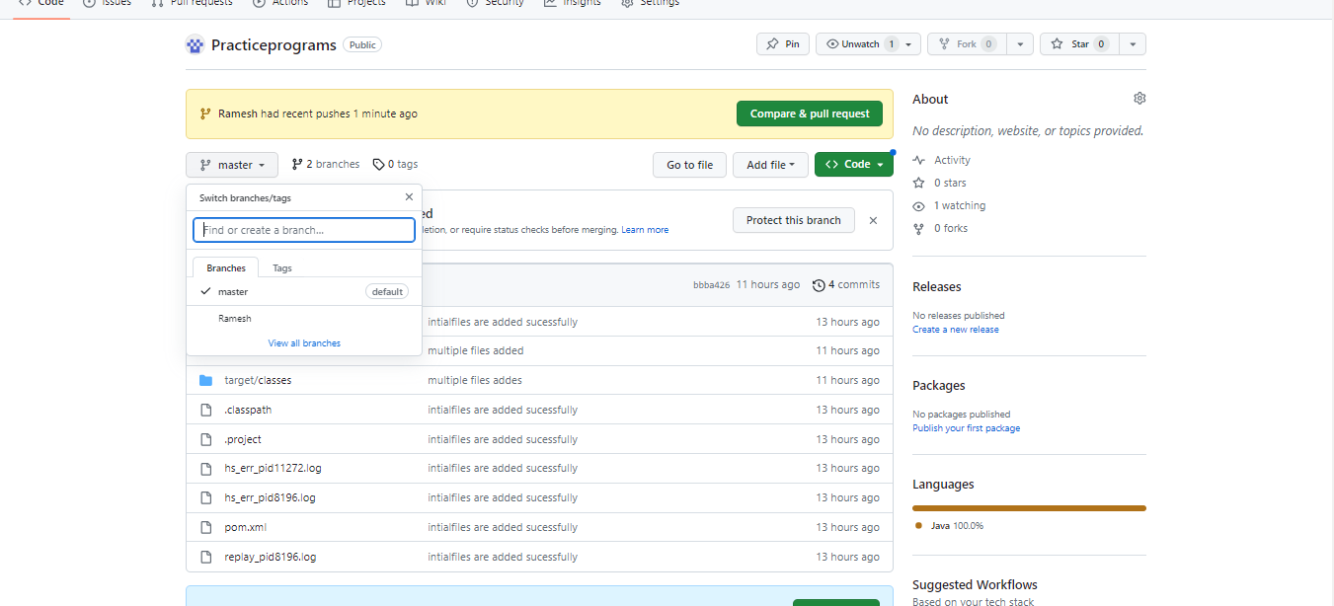

Code is available in only Ramesh Branch why because of the we are not merge the code from Ramesh to master

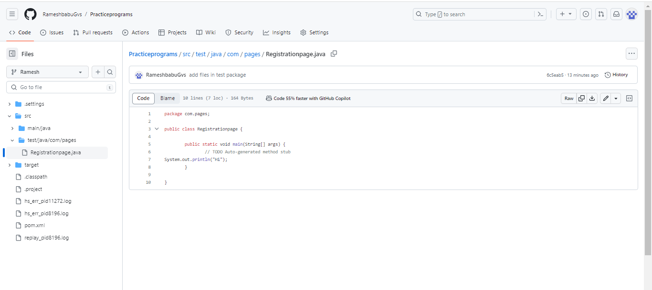

Pull request raised from remote side not from local side

Click the compare & pull request button

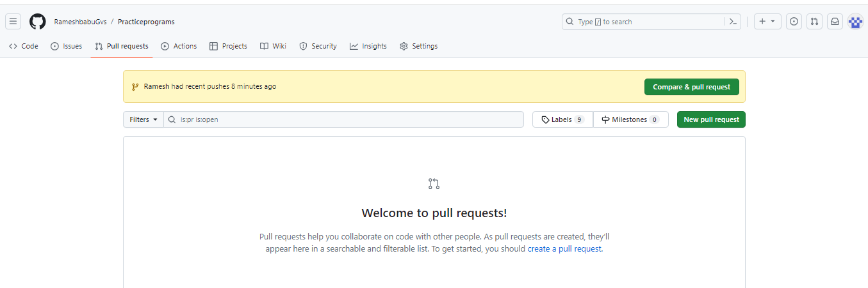

Check from branch to master branch and add comments and click create pull request button

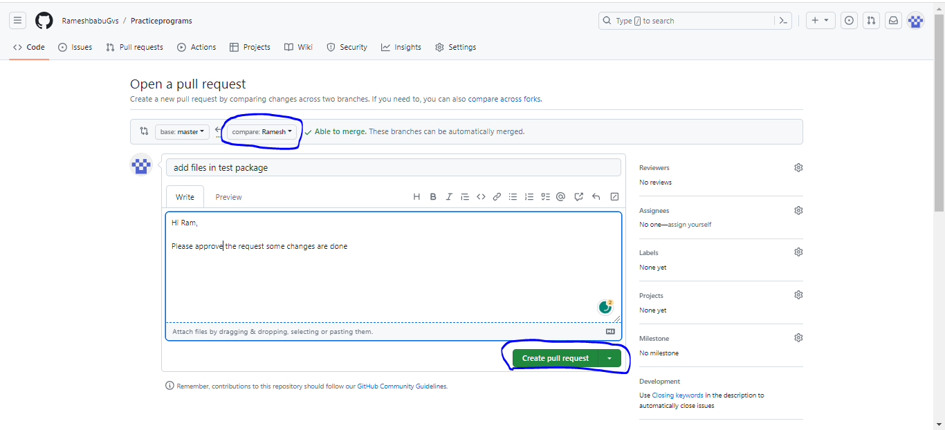

Files has been added successfully and admin has got one pull request also.

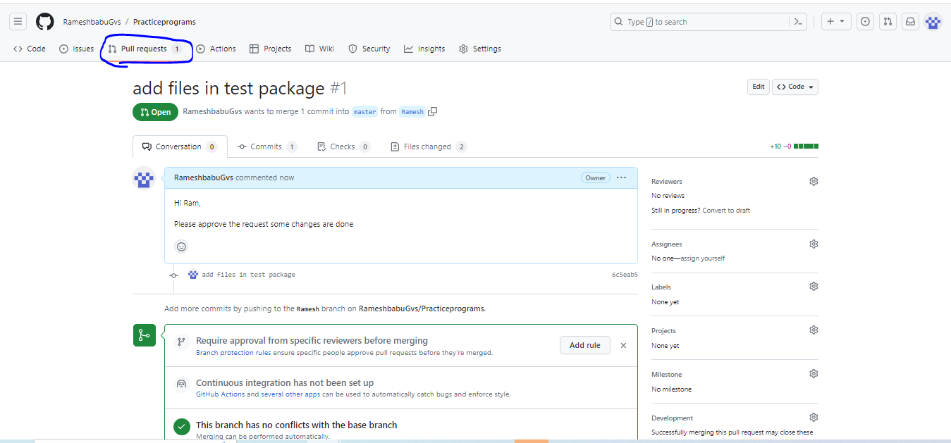

Go to pull request 🡪files changed🡪 see the code🡪 if any reviews or changes need

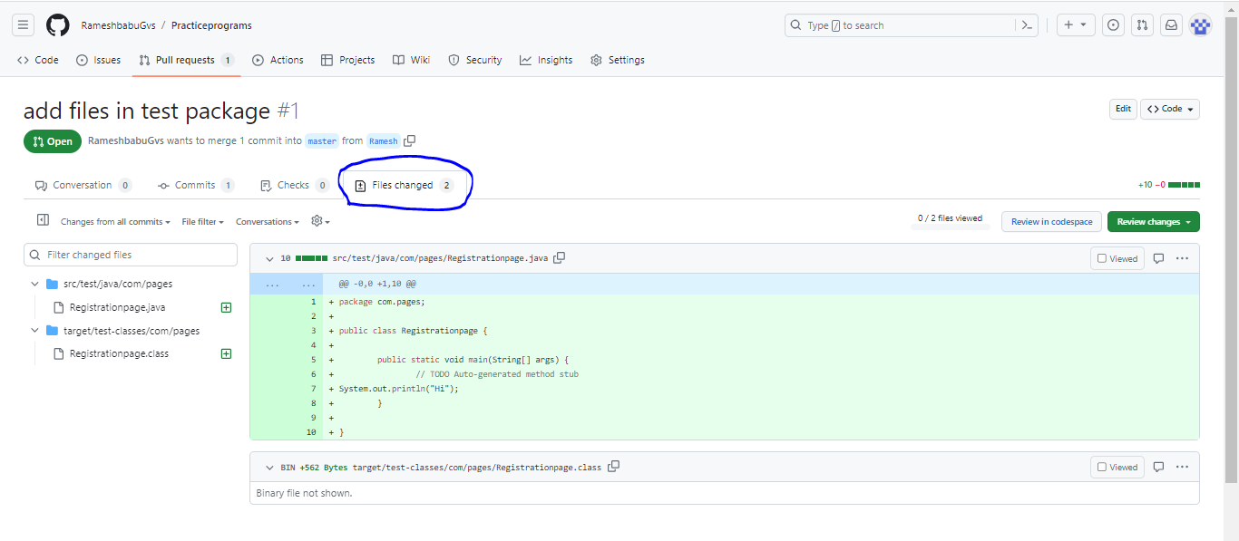

If everything okay, click Merge pull request

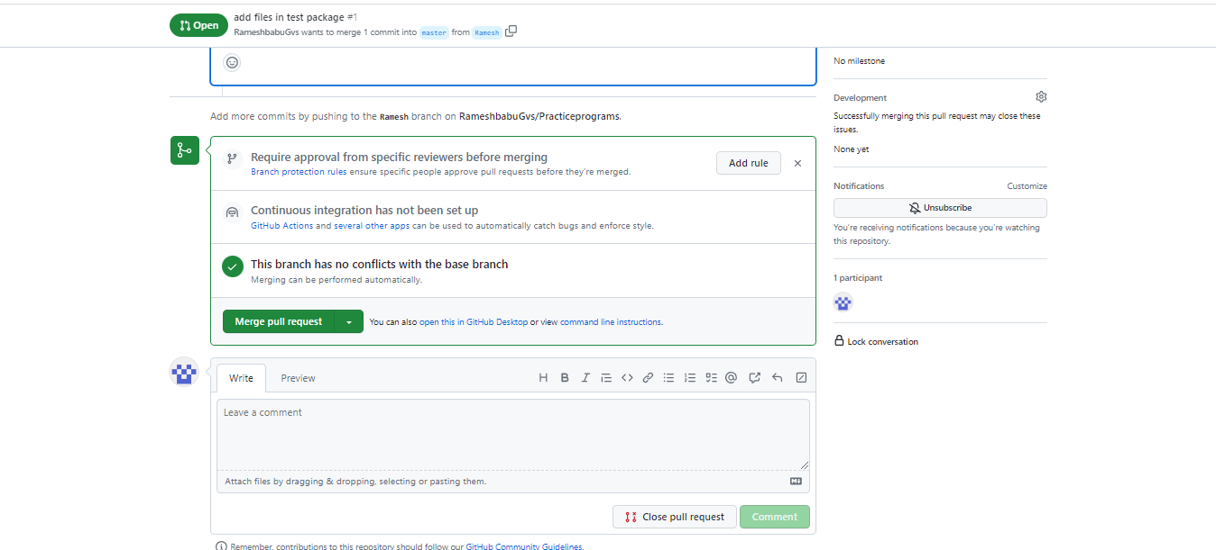

Click confirm merge button

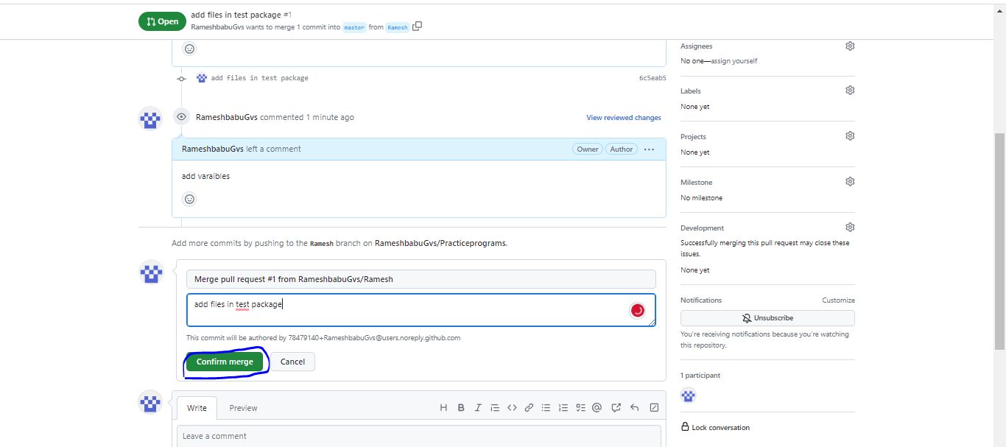

Pulll request has been successfully merged and closed. Merge any one can easily merge after master branch approving

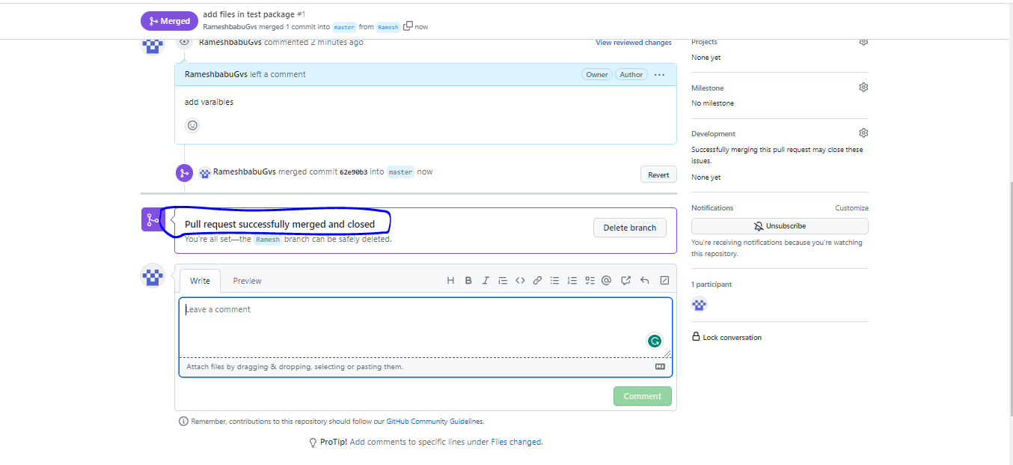

Verify master branch code is updated or not

Updated code is visible in master branch

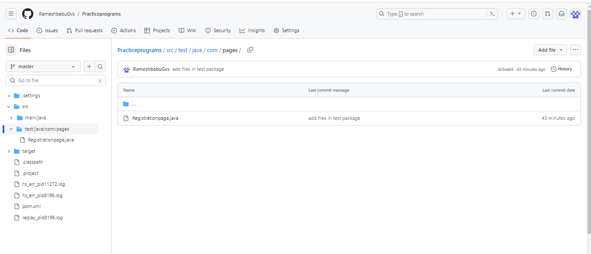

Need to move Ramesh to master branch

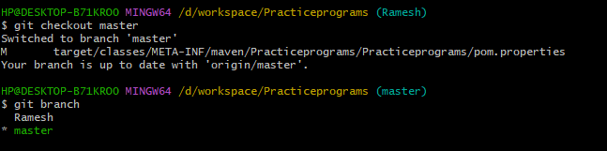

Local master branch don’t have updated code if u want updated code u need pull

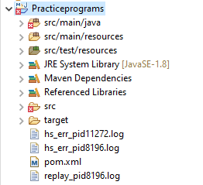

First u can change Ramesh branch to master branch 🡪git checkout master

**git pull origin master**

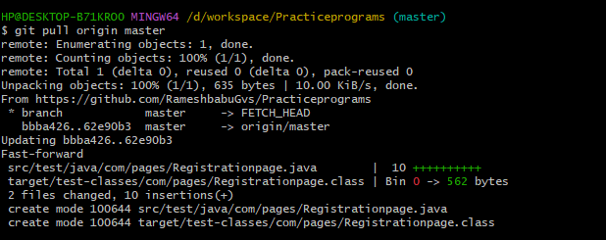

Refresh the local master project now u are able to see updated code

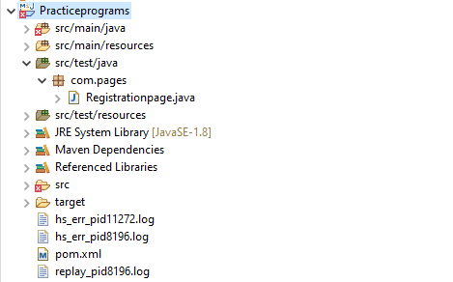

**Git Log Commands**

git log🡪 it shows what actions till we are performed

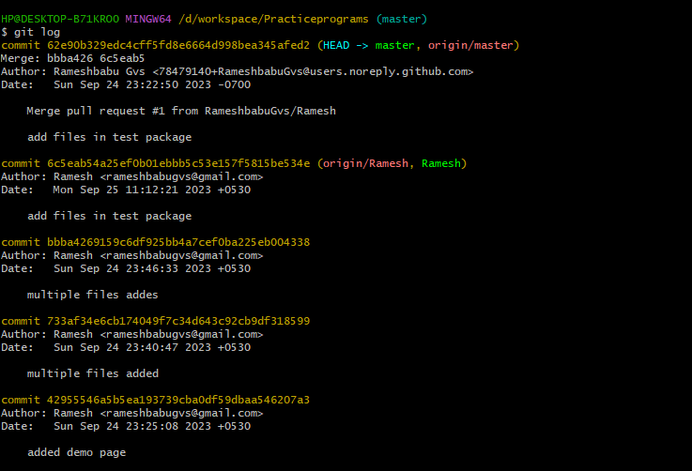

**git log -2 🡪 it shows the author name**

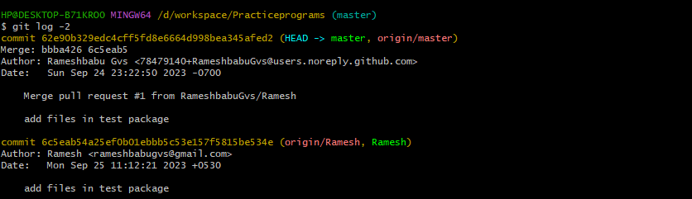

**git log --author="Ramesh"🡪 it shows respective author performed actions**



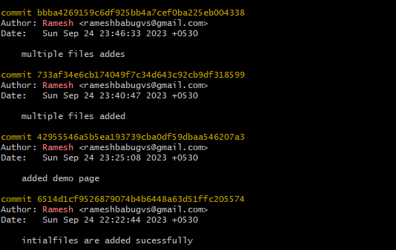

**git log --before='2023-09-26'🡪 it shows what actions we are performed before mentioned date.**



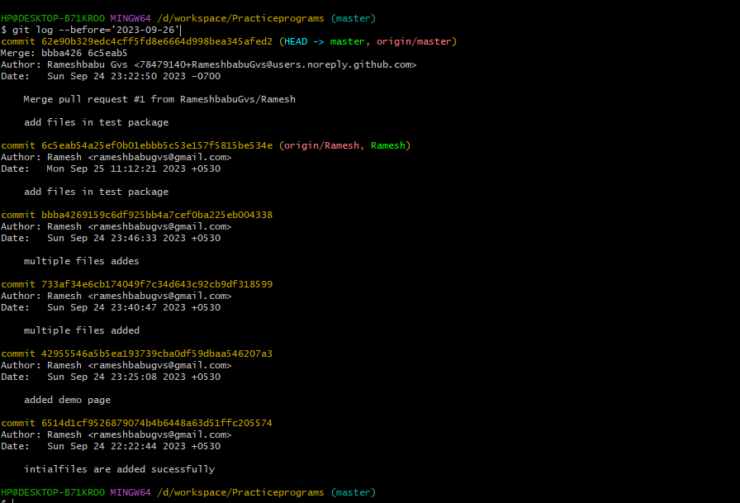

**git log --after='2023-09-24'🡪 it indicates what actions we are performed after date**

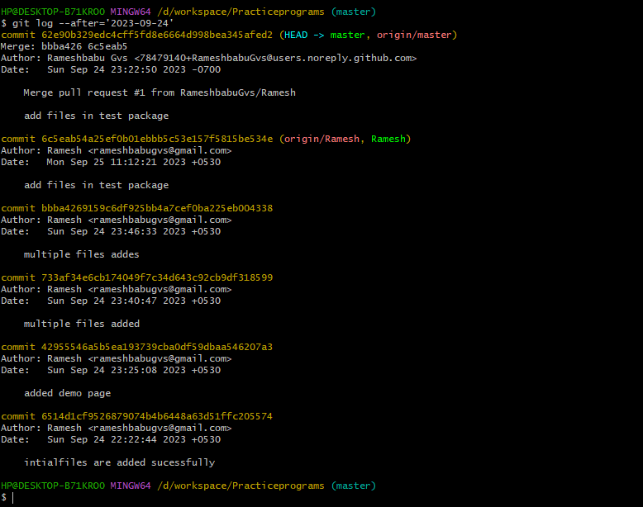

**git log --oneline 🡪 it indicates the only one order information**

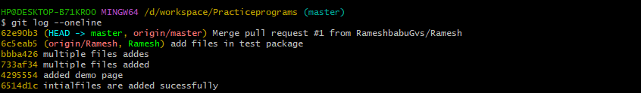

**git log src/test/java/com/pages/Registrationpage.java 🡪it indicates respective file committed details**

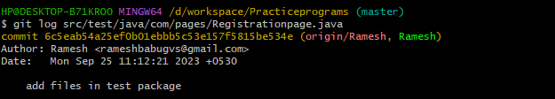

git shortlog 🡪it displays the all contributors commits(Actions)

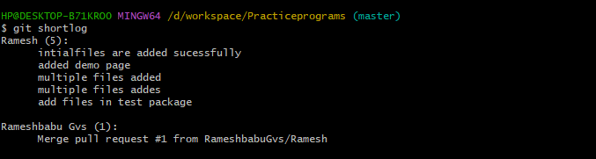

**git blame – it displays the line by line information**

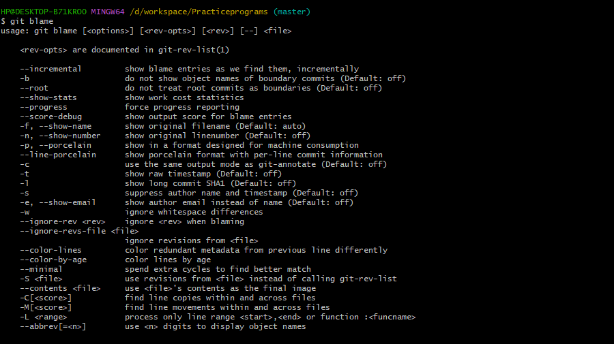

**git blame src/test/java/com/pages/Registrationpage.java 🡪 it displays respective class author details and shows code also**

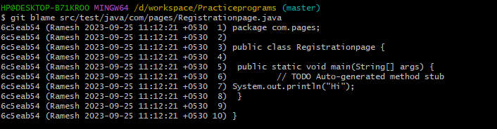

**git tag concept**

**if u are adding the file by using it stores separately with tags section in git hub**

**git add . 🡪add files**

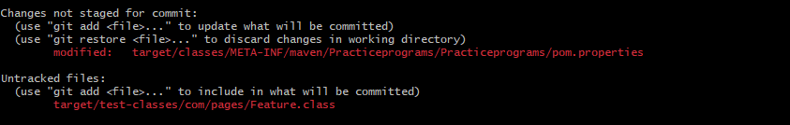

**git commit –m “file added”**

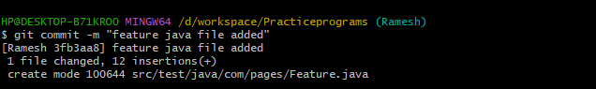

**git tag v1.0🡪 tag is created**



**git push origin v1.0**

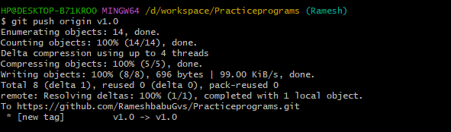

**Code has been successfully pushed into git hub into in tag section**

**Code has been pushed into tag to tag**

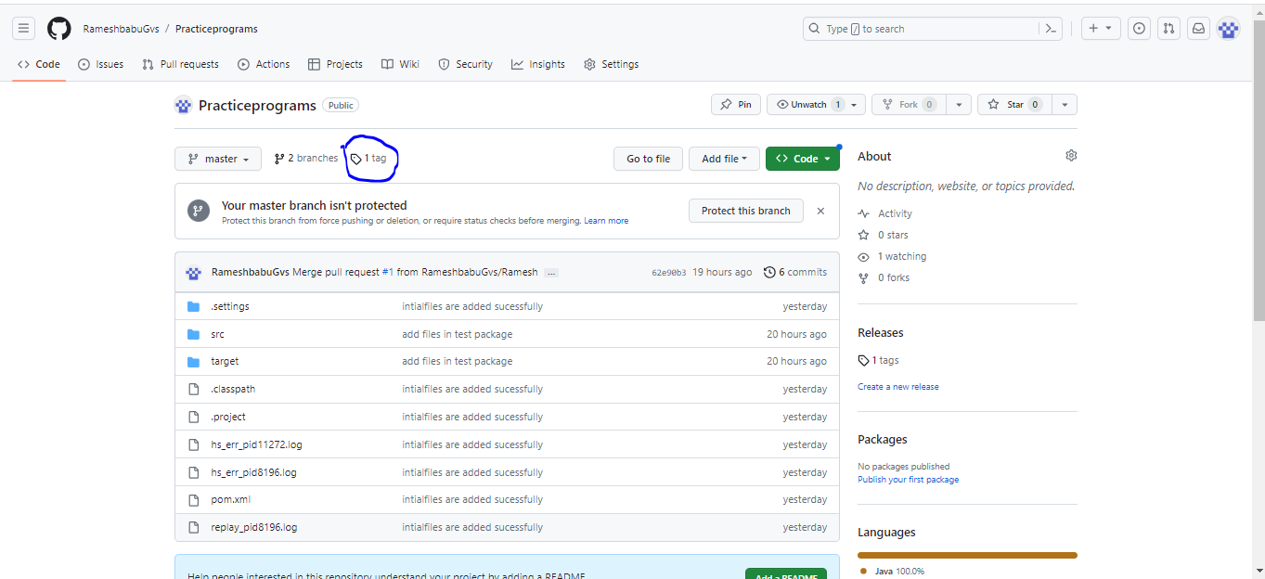

**It displays tag name also please find the below image**

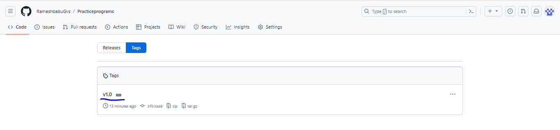

**After few days Added new code has been in same feature java class**

**Again add the code**

**git add .**

**git commit –m “f2 has been added”**

**git tag v2.0 –> tag2 created**

**git push origin v2.0**

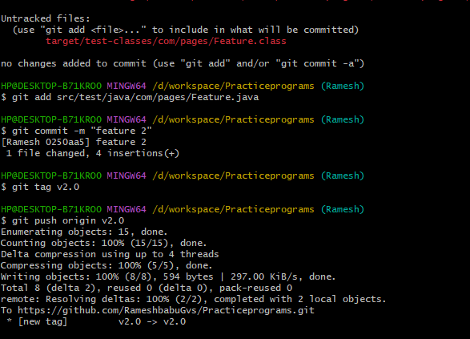

**V2.0 has been updated in github**

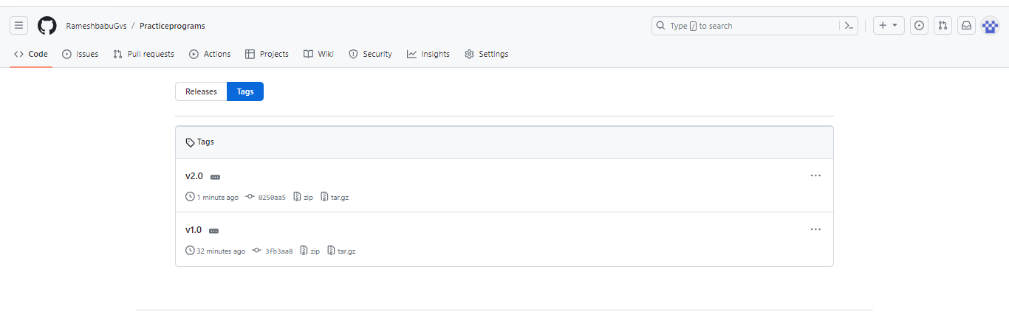

**After few days Added new code has been in same feature java class**

**Again add the code**

**git add .**

**git commit –m “f3 has been added”**

**git tag v3.0 –> tag3 created**

**git push origin v3.0**

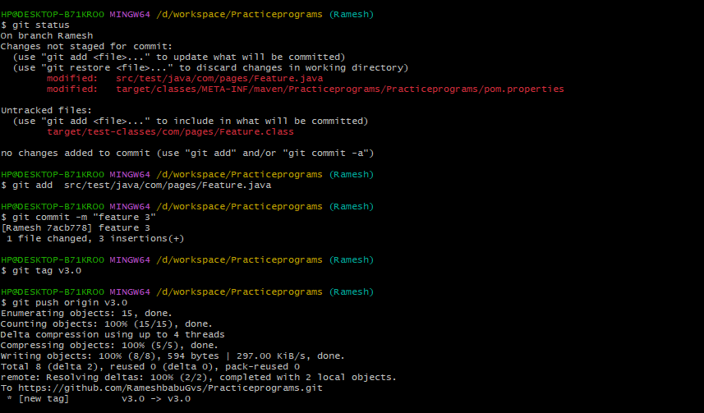

**Code has been updated into git hub**

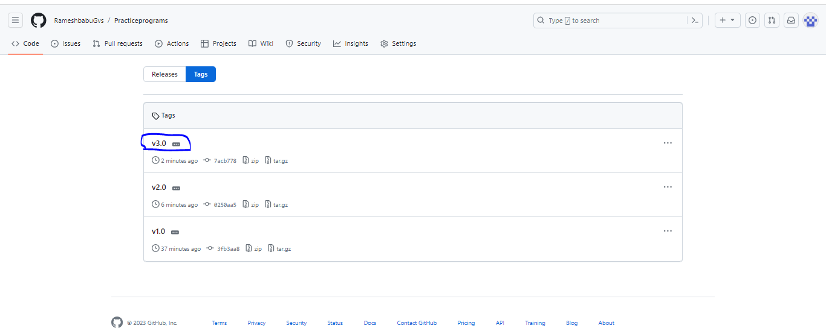

**Next u can release the which tag version u want**

**Goto🡪Releases🡪click Create a new release**

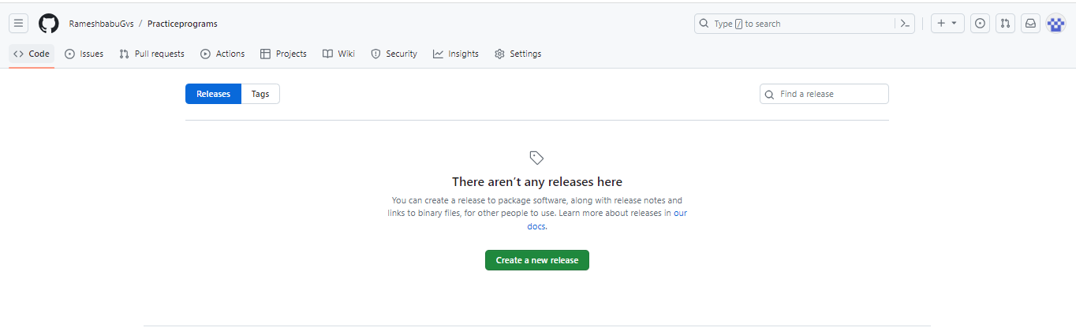

**If u are using tags method Git hub Branch(Ramesh) don’t have updated code with release**

**See below image GitHub do not have updated code**

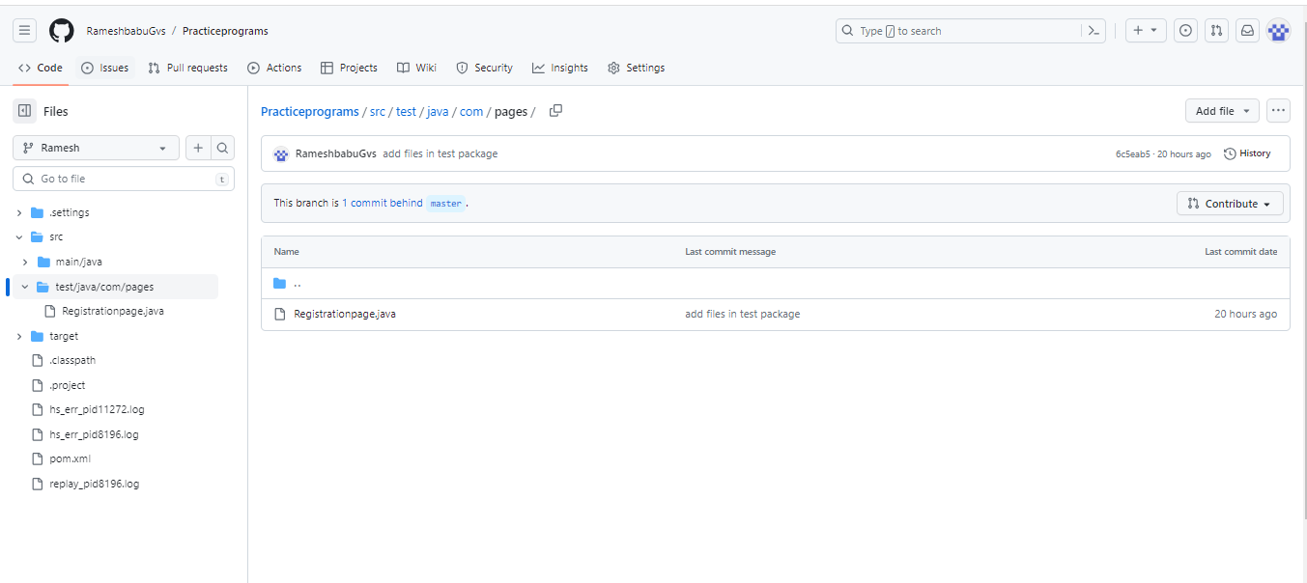

**Choose repective tag and branch**

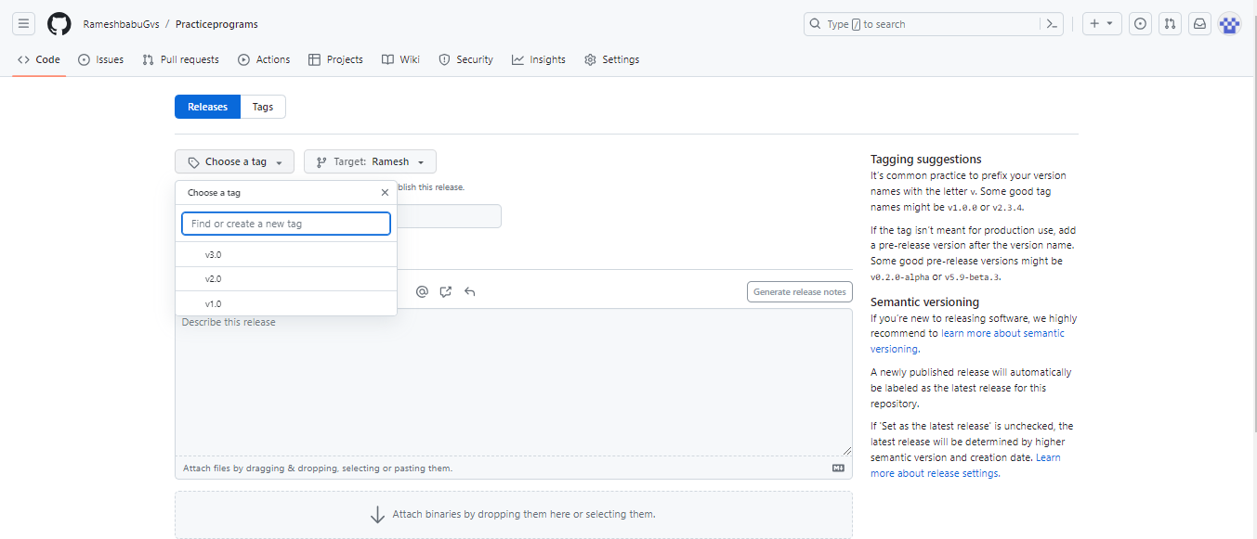

**U can enter the title and description🡪 click Update release button**

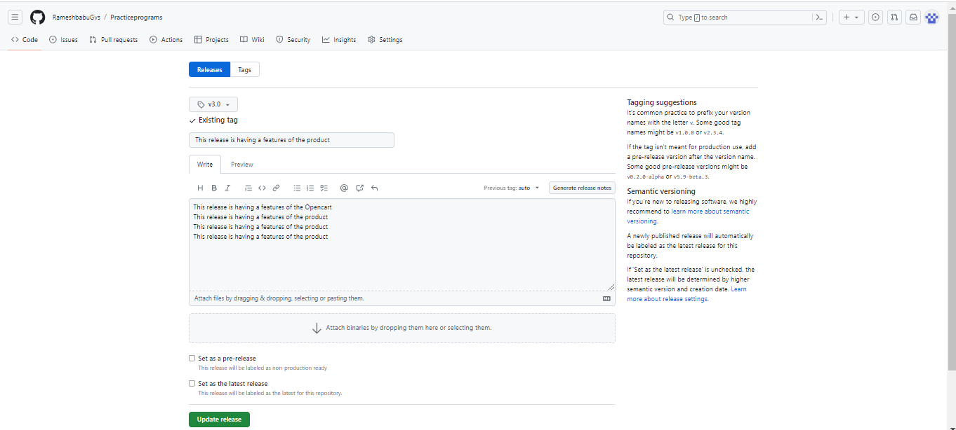

**git show HEAD 🡪it tells Exact last commit details**

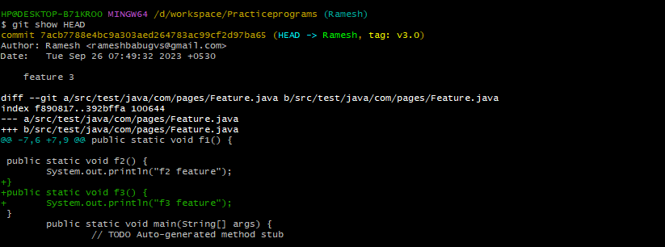

**git show HEAD~2 🡪 it tells Exact last 2 commit details**

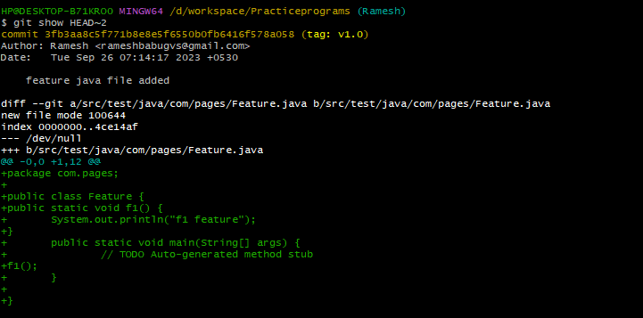

**git branch –r🡪 if u want find out the remote(Git hub) branches u can use command**

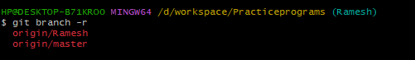

**git branch –vv 🡪it displays the local and remote branchs and tags**

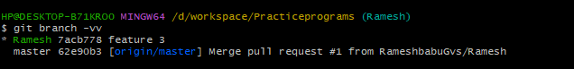

**Creation of branch 🡪 git branch testing**

**Status of branches**

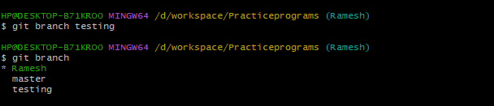

**Deletion of branch in locally🡪 git branch -d testing**

**Status of branches**

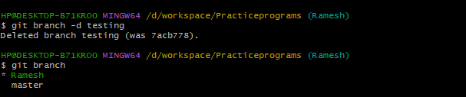

s

**git checkout -b Naveen 🡪 this command indicates branch creates automatically and shifted to Naveen**

**branch also**.

**It displays three branches and shifted to Naveen branch**

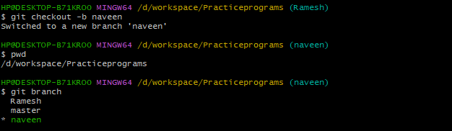

**If I want to delete the branch from remote side**

**First u need add the code into a branch,commit,push**

**Code has been added successfully and branch also displays in github**

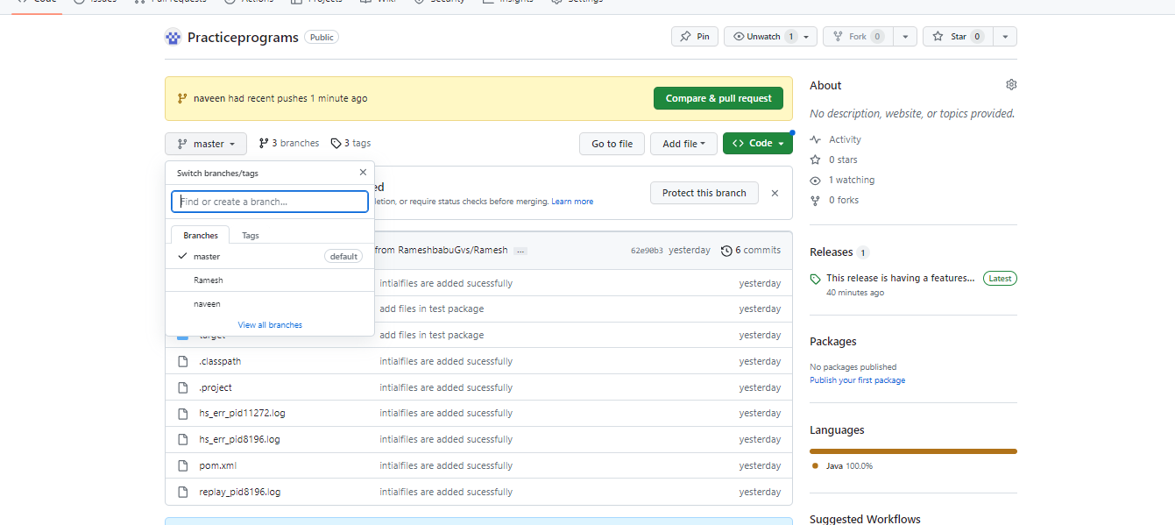

**git push -d origin naveen 🡪Deletion of remote branch**

**branch has been deleted successfully in remote (Git Hub)**

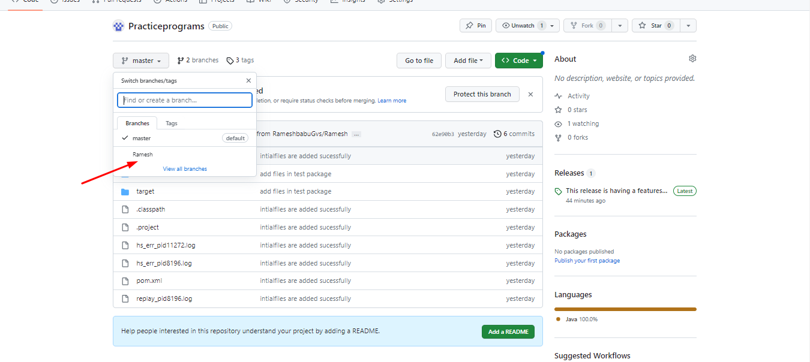

**Deletion of branch in locally🡪 git branch -d testing**

**Status of branches**



**git pull origin master 🡪 it means it pulls the updated code from respective branch**

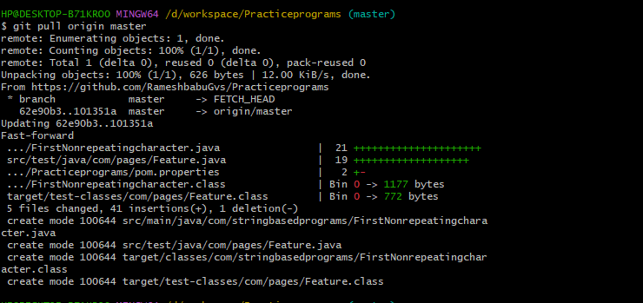

**If u are try again it showing uptodate**

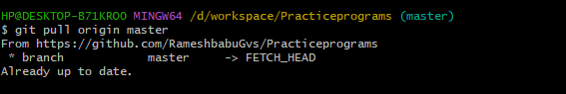

git merge master –-> master branch merge the entire code to selenium branch

